***Course No: SWE 430***

***Information and Network Security Lab***

**Assignment on**

**Lab 4: Programming Symmetric & Asymmetric Crypto**

**Submitted To:**

Partha Protim Paul

Lecturer, IICT, SUST

**Submitted By:**

Promi Mojumder

Reg No: 2019831038

IICT, SUST

**Lab 4: Programming Symmetric & Asymmetric Crypto**

1. **Importing the necessary libraries:**

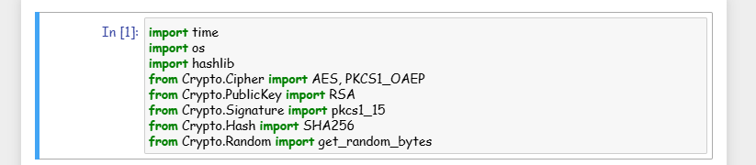

1. **AES encryption/decryption with two key lengths, 128 and 256 bits, and two modes ECB and CFB:**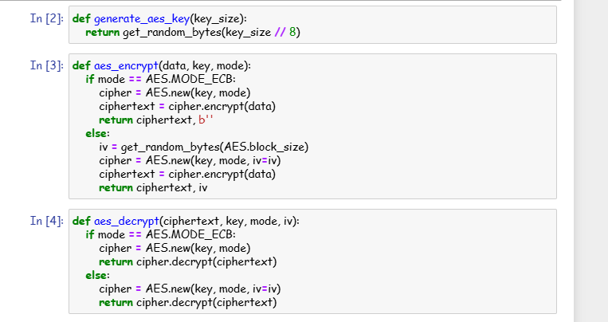

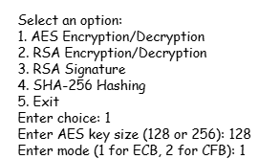

1. **RSA encryption and decryption:**

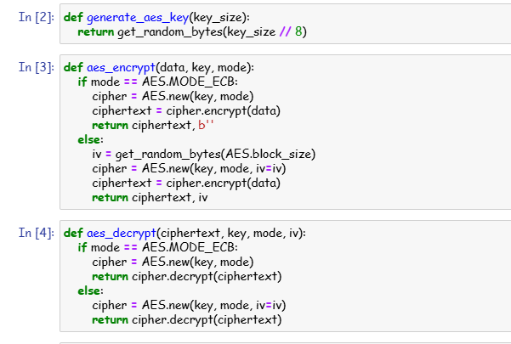

1. **RSA Signature:**

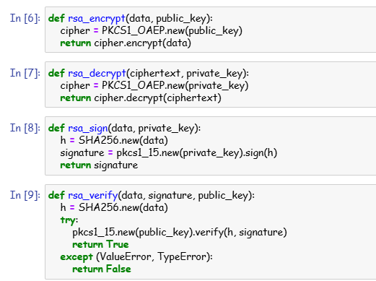

* **RSA signature:**



1. **SHA-256 hashing:**

